# Jay ECU Car Adapter

## Purpose

The purpose of Jay’s ECU Car adapter is to adapter a current wiring harness that plugs into a Cinch connector with a new harness that Jay can make. He has the mating connectors for the existing ECU, but he needs another set of connectors, the mating connectors, the contacts, etc.

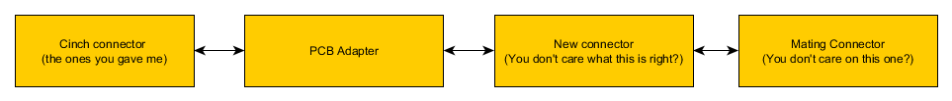

The table below summarizes the various components that need to be purchased

|  |  |  |  |
| --- | --- | --- | --- |
| Description | Digikey Part Number | Cost | Quantity |
| PCB 60 pin connector | C581-01-60-001-ND | $50.69000 | 3 |
| 30 pin plug in connector keying style A | C581-01-30-028-ND | $12.70000 | 2 |
| 30 pin plug in connector keying style B | C581-01-30-029-ND | $12.70000 | 2 |
| Terminals | C425-00-00-873/PCS-ND | $17.745 | 150 |
| Seal Plug | C581-00-00-011-ND | $9.60 | 100 |
| Crimp tool | C599-11-11-615-ND | $566 | 1 |
| PCBs | Nick-12345;) | $32 | 6 |

A PCB adapter will be created that will directly map pins on one Cinch 581-01-60-001 connector to pins on a matching 581-01-60-001 connector. Then Jay can make his own wiring harness. Total cost minus the crimp tool is $256.22.